Milford Infants’ School Year 1 Curriculum Letter Autumn Term 1st Half 2026

Hello and welcome to Year 1. We have all been super impressed at how the children have returned after the summer holidays. They are keen to get stuck in and seem to be loving their learning so far
Please could we remind to label all of your children’s clothing. We have very few named jumpers which makes returning them to their owners very tricky!

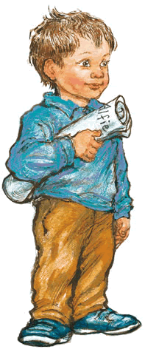
Literacy
Writing
In Literacy the children will be producing work based on the
‘Alfie’ stories written by Shirley Hughes. They will be
exploring the various experiences, feelings and emotions
Alfie has throughout the different stories and relating them to that of their own. In their writing the children will be focussing on applying their phonics as well as using capital letters, full stops, finger spaces so their work can be read by themselves and others.
Literacy
Phonics We have loved getting into our Supersonic Phonic Friends Scheme. The children are picking up the actions well and enjoying how fun and active our lessons are. We have begun by recapping the digraphs that we learnt in Reception.
This is to ensure that we are recognising them quickly when Reading and using them correctly.
The children will bring home spellings this week to help them practise what they have learnt at home.
Reading
The children will have the opportunity to change their books on Mondays, Wednesdays and Fridays. Please try to hear them read even just a couple of pages at a time as this really does have a huge impact on their progress.

Please make sure you write in their reading record when they have read to you so that we know they are ready to change their books. Thank you for your help and support with this.

Science
The Human Body and the senses.
The children will be learning to identify, name, draw and label the basic parts of the human body. They will be using equipment such as the ‘Digi –scopes’ to observe and look at different parts of their bodies in more detail. The children will also be exploring their senses and finding out which part of their body is associated with each sense.

Maths
Our focus this half term will be on securing and developing
the children’s understanding of place value working with
numbers 0 –10 then up to 20. The children will be learning to identify and represent numbers using objects and pictorial representations including Diennes and Number Lines. They will be finding 1 more or 1 less than a given number and explore using the mathematical language of equal to, more than, less than (fewer), most and least.

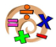
Look at Me!
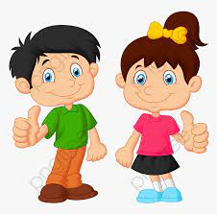

RE
Belonging In our RE lessons this half term the children will start off by thinking about what it means to belong to a family. We will then explore the theme across different religions including Christianity, Judaism and Islam. We will look at the different symbols used in these religions and find out about some of their practises.

Computing
E-safety – The focus will be on being kind and responsible when using technology.

Parts of a Computer – The children will learn to identify examples of technology in the
classroom, name the main parts of a laptop and begin to understand what each part is used for. The Children will be able to switch on a PC device and use a keyboard to log on.
Children will learn the name and function of some of the keys on the keyboard.
on a keyboard to complete a task.

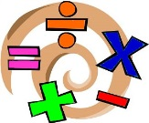
PSHE
Our Happy School

We will be talking lots about our School Golden Rules, discussing why we have rules .
We will also be talking about how we are the same and different from my friends and about our feelings.

PE
Hoopball and Multiskills
The children will have one PE session with their teacher where we they will be focussing on Cricket. We will be learning how to hold a bat and hit a ball. We will also be working on our bowling and fielding skills.
The children will have another PE session with their sports coaches which will focus on Multiskills.
Poplar Tuesday and Friday
Pine Tuesday and Wednesday
Rowan Tuesday and Friday

Please ensure your child has a named P.E kit in school at all times including jogging bottoms to wear outside if it is cold. Please ensure names are also in sports shoes.

Art
Portraits
Using mirrors we will carefully observe our skin, hair and eye colour. We will then be using pencils and watercolours to create fine portraits of our selves; mixing colours where appropriate.
Later on in the half term we will move onto drawing from our imaginations, observation and memory.
Experiment with colour mixing using both chalk pastels and paints and be able to talk about how they made different colours.



